9,6 or 24/25

**R Computer Lab #2**

Alda Magnúsdóttir Jacobsen

Hildur Mist Pálmarsdóttir

Tinna Brá Sigurðardóttir

Þórdís Gísladóttir

1.

**a) Which item was the easiest item and which item was the hardest? (2 points)**

Item 10 (marked in red on output) is the hardest one and item 5 (marked in green on output) is the easiest one.

Output :

Discrimination Difficulty Guessing

Item 1 1 -1.40938612 0

Item 2 1 -0.35055656 0

Item 3 1 -0.90318970 0

Item 4 1 -0.97412011 0

Item 5 1 -1.62671110 0

Item 6 1 0.02533657 0

Item 7 1 -0.41418545 0

Item 8 1 -0.87993298 0

Item 9 1 -0.91498121 0

Item 10 1 0.52959427 0

Item 11 1 -1.17125435 0

Item 12 1 -0.04749604 0

Item 13 1 0.15008663 0

Item 14 1 -0.74253017 0

Item 15 1 -0.74245332 0

Item 16 1 0.36963876 0

Item 17 1 -0.84513136 0

Item 18 1 -1.45145349 0

**b) Provide a 95% confidence interval for the easiest item and interpret it. (2 points)**

-1.62671110 +/- 1.96 * 0.1320051 = -1.367981003 / -1.885440996

There is 95% chance that the confidence interval contains the true item difficulty which lies between -1.367981003 and -1.885440996.

Output :

Discrimination SE Difficulty SE Guessing SE

Item 1 NA 0.1267448 0

Item 2 NA 0.1128011 0

Item 3 NA 0.1178581 0

Item 4 NA 0.1188426 0

Item 5 NA 0.1320051 0

Item 6 NA 0.1118476 0

Item 7 NA 0.1131572 0

Item 8 NA 0.1175527 0

Item 9 NA 0.1180162 0

Item 10 NA 0.1136598 0

Item 11 NA 0.1220123 0

Item 12 NA 0.1118797 0

Item 13 NA 0.1119630 0

Item 14 NA 0.1159197 0

Item 15 NA 0.1159189 0

Item 16 NA 0.1126941 0

Item 17 NA 0.1171115 0

Item 18 NA 0.1276902 0

**c) Provide a plot that contains both the easiest and the hardest item. (1 point)**

The black line is the easiest item and the red one is the hardest.

The ability estimate for the black line is -1.6

The ability estimate for the red line is 0.8

Output :

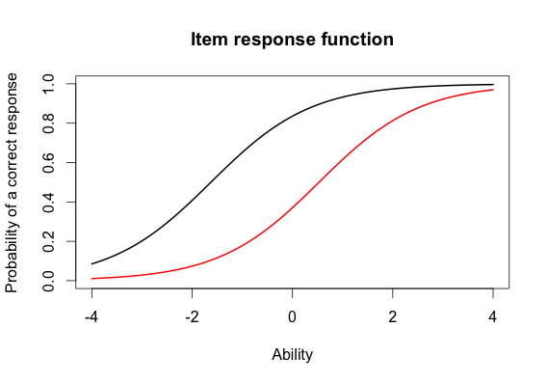

**d) What would we expect the probability of a correct response would be for someone who had an ability score of 0 for these two items? (2 points)**

The probability of a correct response for someone who had an ability score of 0 would be 0.8 for the easiest item and 0.38 for the hardest item.

Output : Same as in c.

**e) What was the score of the person who did the best on the test? What was the score of the person who did the worst on the test? (2 points)**

The score of the person who did best on the test is 3.999921

The score of the person who did worst on the test is -3.999947

Output :

> min(est_abl$est) # Prints the minimum score

[1] -3.999947

> max(est_abl$est) # Prints the maximum scores

[1] 3.999921

**f) Provide a 95% confidence interval for the estimated ability for the student who did the best on the test and interpret it. (2 points)**

3.999921 + 1.96 * 2.204373 = 8.32049208

3.999921 – 1.96 * 2.204373 = -0.32065008

There is 95% chance that the confidence interval contains the true ability score which lies between -0.32065009 and 8.32049208

Output :

est sem n

49 3.999921 2.204373 18

2.

**a) Please state the three items you selected. (1 point)**

We chose item 5, 10 and 15.

**b)Provide a plot that contains these three items’ information functions. (1 point)**

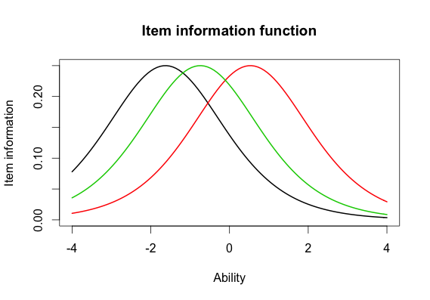

**c) What is the same about these items’ information functions? What is different? Hint: This can be a very short answer. (2 point)**

The curves are the same but the location is different.

**d) Provide a plot of the test information function. (1 point)**

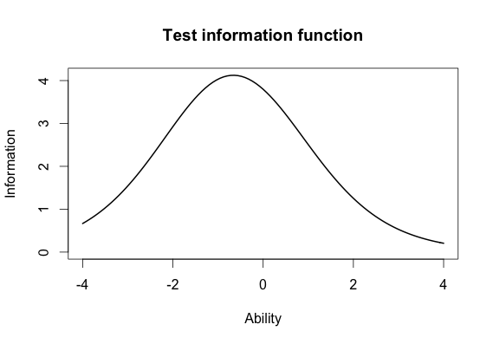

**e) Where is the majority of the information for this test located? (1 point)**

From 0 to -1.

3. **Comparing the 2-PL**

**a)Which item had the highest discrimation? Which one had the lowest discrimination? (2 point)**

Item 8 had the highest discrimination (marked in red in the output).

Item 12 had the lowest discrimination (marked in green in the output).

Output :

Discrimination Difficulty Guessing

Item 1 0.6326689 -2.00058101 0

Item 2 1.5469622 -0.26815483 0

Item 3 1.2534918 -0.77297206 0

Item 4 0.9842598 -0.97706755 0

Item 5 1.6407242 -1.19389580 0

Item 6 1.4702029 0.01833431 0

Item 7 0.5632837 -0.65124651 0

Item 8 2.2881772 -0.56753253 0

Item 9 1.8004066 -0.64761748 0

Item 10 1.1142107 0.48542889 0

Item 11 1.0344119 -1.13363005 0

Item 12 0.3329130 -0.12951933 0

Item 13 0.3369968 0.36344671 0

Item 14 0.6608229 -1.01479867 0

Item 15 1.5980393 -0.55640285 0

Item 16 1.0362116 0.35459121 0

Item 17 1.8591845 -0.59017915 0

Item 18 1.2808752 -1.22177042 0

**b) Are the items that were the easiest and hardest in the Rasch model, also the easiest and hardest in the 2-PL? (1 point)**

Item 10 was the hardest in the Rasch Model and also in 2-PL but Item 5 was easiest in the Rasch Model but Item 1 was the easiest in 2-PL

Output :

Discrimination Difficulty Guessing

**Item 1 0.6326689 -2.00058101 0**

Item 2 1.5469622 -0.26815483 0

Item 3 1.2534918 -0.77297206 0

Item 4 0.9842598 -0.97706755 0

Item 5 1.6407242 -1.19389580 0

Item 6 1.4702029 0.01833431 0

Item 7 0.5632837 -0.65124651 0

Item 8 2.2881772 -0.56753253 0

Item 9 1.8004066 -0.64761748 0

**Item 10 1.1142107 0.48542889 0**

Item 11 1.0344119 -1.13363005 0

Item 12 0.3329130 -0.12951933 0

Item 13 0.3369968 0.36344671 0

Item 14 0.6608229 -1.01479867 0

Item 15 1.5980393 -0.55640285 0

Item 16 1.0362116 0.35459121 0

Item 17 1.8591845 -0.59017915 0

Item 18 1.2808752 -1.22177042 0

c) **What is the correlation between the ability estimates on the Rasch model and the 2-PL? If your interest was solely on estimating person abilities, do you think you would draw the same conclusions from both models? Why? (2 point)**

The correlation between the ability estimates on the Rasch model and the 2-PL is 0.9709497 which tells us that a person that was high on the Rasch model is high on the 2-PL. So yes, I could in this case draw the same conclusions from both models.

Output :

> # Correlation between the ability estimates

> cor(twopl_abl$est,est_abl$est)

[1] 0.9709497

**d) Provide a plot of the item information function for the three items you selected in Question 2 but this time for the 2-PL model. (1 point)**

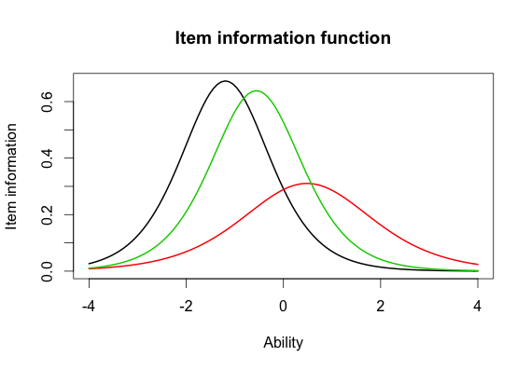

e) **For the 2-PL model, how do the item information functions for these items differ? How do the 2-PL item information functions from these items differ from their Rasch item information functions? (2 point)**

The red line has the widest range, small information and the lowest discrimination. The black line has the highest item information and a large discrimination. The green has a slightly lower item information than the black one and a little larger discrimination. The black line has the most information about the item difficulty but the red one has the least because it is wide. The black one is the easiest question.

What about the Rasch model, how do they compare? -1